Handwriting letter formations: Curly caterpillar family

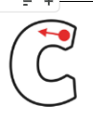 | Pull down, push along the line
 | Pull down, push, pull, push along the line
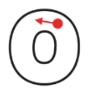 | Pull down, push along the line, up
 | Pull down, push along the line, up, down bump
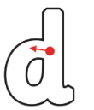 | Pull down, push along the line, up, up, down bump
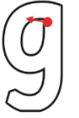 | Pull down, push along the line, up, down, down under, hook
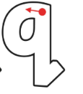 | Pull down, push along the line, up, down, down under, slope up
 | Push, curve up, pull in a loop, push along the line
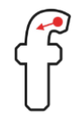 | Pull down, down, push
Handwriting letter formations: One armed robots

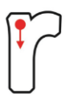 | Down bump, up, push
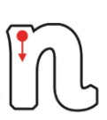 | Down bump, up, push over, down bump
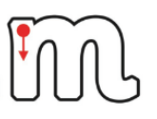 | Down bump, up, push over, down bump, up, push over, down bump
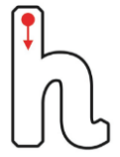 | Down bump, up, push over, down bump
 | Down bump, up and over, join up
 | Down, down under, up, up and over, join up
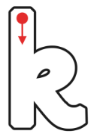 | Down bump, up, push, loop around, kick

Handwriting letter formations: Long ladder letters

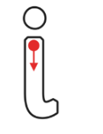 | Down, hook along the line, off, dot
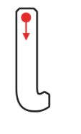 | Down, hook along the line
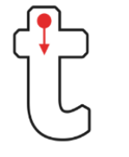 | Down, hook along the line, off, push across
 | Down, hook, off, dot
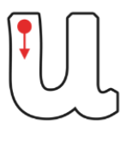 | Down, push along the line, up, down bump
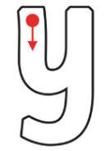 | Down, push along the line, up, down, down under, hook

Handwriting letter formations: Zig-zag monsters

 | Slope down, slope up
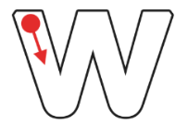 | Slope down, slope up, slope down, slope up
 | Slope down, off, go to the top, slope down
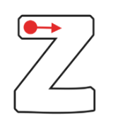 | Push across, slope down, push across

