Guildhall Feoffment Primary School

KEY STAGE 2 VISITING AUTHOR AND WRITING WORKSHOPS
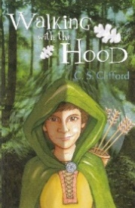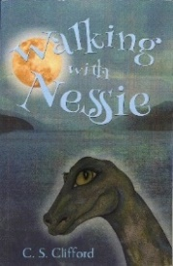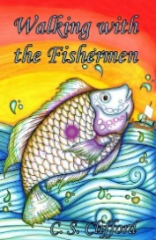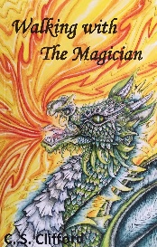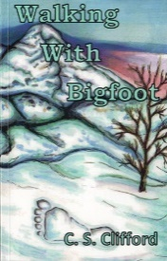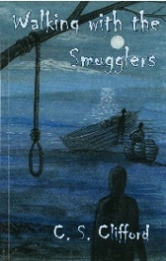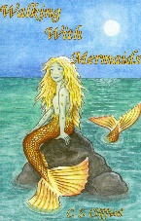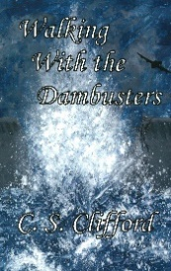
THE WALKING WITH SERIES FOR 8-13 YEAR OLDS at £6.99

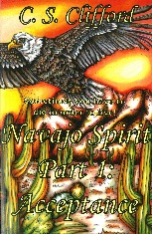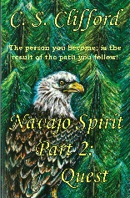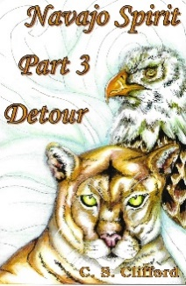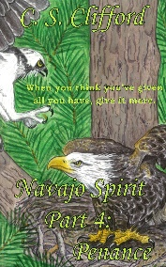
THE NAVAJO SPIRIT SERIES FOR OLDER READERS at £7.99

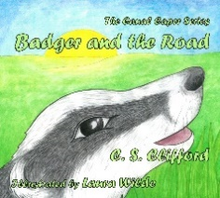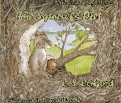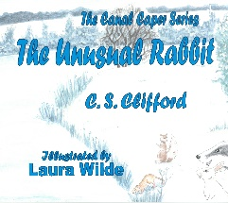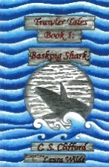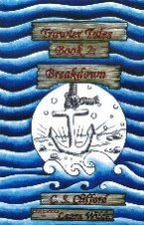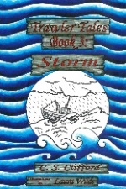
CANAL CAPER SERIES FOR 6-9 YEAR OLDS at £7.99 TRAWLER TALE SERIES FOR 6-9 YEAR OLDS at £5.99
(More detail at www.csclifford.co.uk)

On the 16th-19th of October, we have arranged for KS1 and 2 to have a writing workshop experience with author C. S. Clifford. The children in all year groups will receive a writing challenge followed by class workshops linked to the visiting author’s books.

Children may purchase a copy of one of C. S. Clifford’s books on the day; alternatively, to secure a copy, they can order a copy in advance using the slip below. To pre-order, please look at the following website: www.csclifford.co.uk to decide which book you wish to purchase and complete the slip below. Slips must be returned by ------------------------.

At the end of the day, Steve Clifford will be available to sign any purchased books and meet parents and children.

We look forward to an exciting day
Kind regards,

Child’s Name:--------------------------------------------------------------------- Class:----------------------------------------------

I wish my child to purchase-------------------------------------------- and enclose the amount of -----------------------
for them.

Signed:--------------------------------------------------- Relationship to child:---------------------------------------------------

